**JAVA ECLIPSE MAVEN INSTALLATIONS**

**JAVA INSTALLATION**

**Step 1)** Go to <https://www.oracle.com/java/technologies/javase-downloads.html>

Click on JDK Download for Java

Step 2) Follow the steps and you are almost done.

**ECLIPSE INSTALLTION**

Download Eclipse for Java Developers, extract and save it in any drive. It is totally free. You can run ‘eclipse.exe’ directly so you do not need to install Eclipse in your system.

1) Go to [***http://www.eclipse.org/download***s](https://www.eclipse.org/downloads).

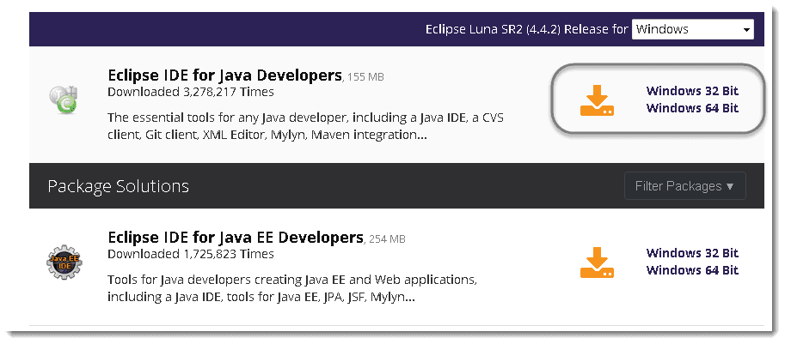

2) For Windows users, you will have to know what type of version of your ***OS*** you have. If your computer is a ***64 bit*** Windows, select Windows 64 and if you have a ***32 bit*** Windows, select Windows 32 bit.

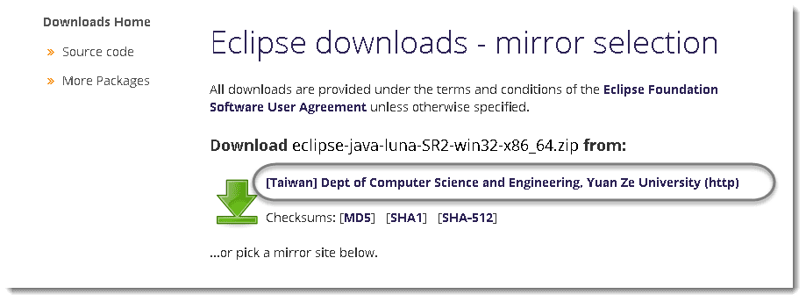

3) ***Save*** the ***.zip*** file to your disk.

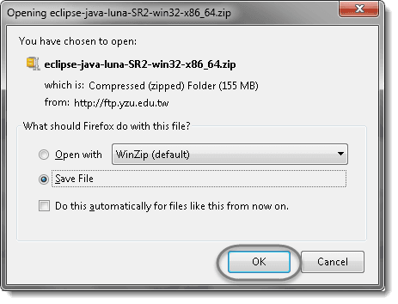

4) Once you have downloaded the Eclipse archive you will need to **Extract**the zip file, which will create the unzipped Eclipse folder.

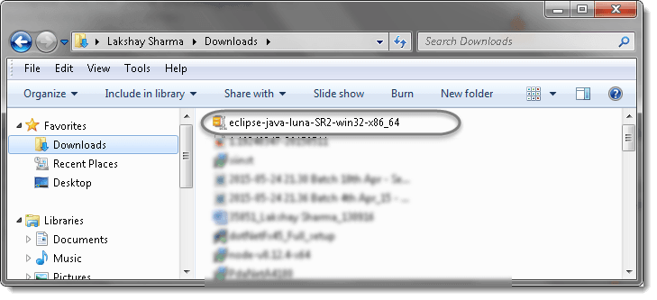

5) You may want to ***Extract*** the archive to the root of ***C: drive***, thus creating the folder “***C:eclipse***”, or just moved the extracted eclipse folder to the root of C: drive if you extracted it already. I prefer to leave it as it is.

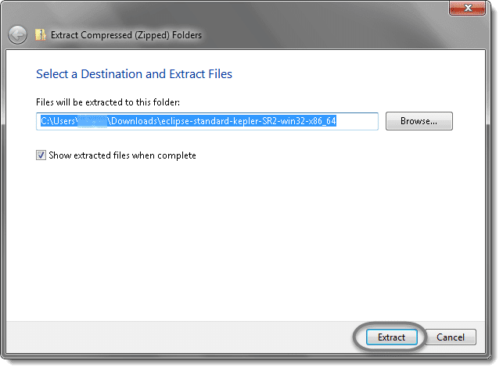

6) Let the extraction process finished.

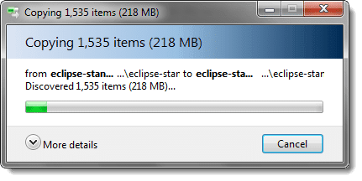

7) ***Open*** the eclipse folder.

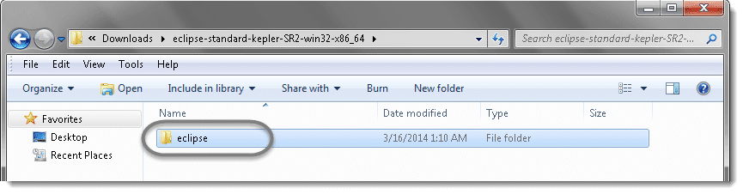

8) Since Eclipse IDE does not have any installer, there will be a file inside the Eclipse folder named ***eclipse.exe***. You can double click on the file to run Eclipse.

***Note:***(This step is not required, but it’s strongly recommended.) Right-click the Eclipse Icon and press “Send To” -> “Desktop (Create Shortcut).” Now you will be able to launch Eclipse from your desktop.

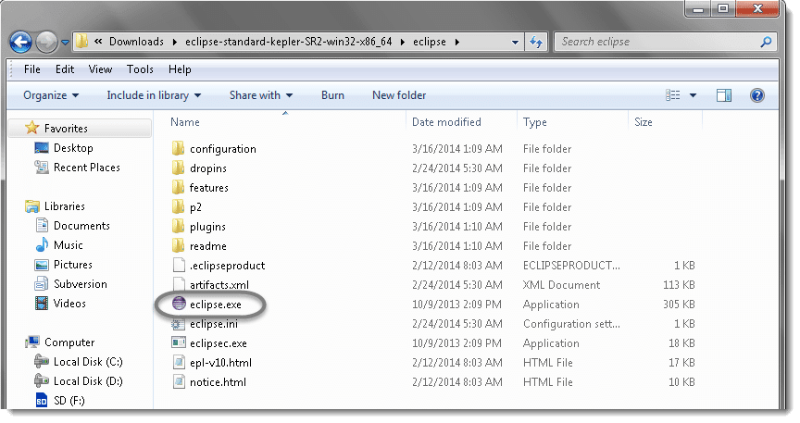

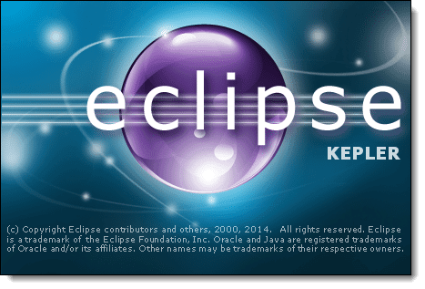

9) Create a ***workspace*** folder where you will contain all the program files you create. You can choose whatever place you want for your workspace, but it’s easiest to just use the default you’re given.

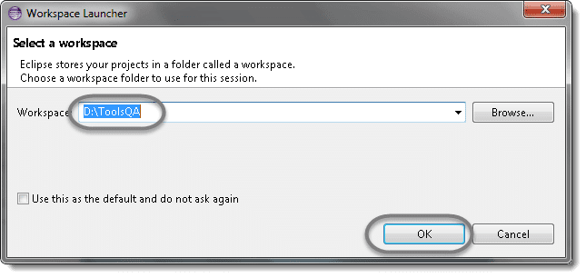

10) You may see the window like this, this is the Welcome window for Eclipse.

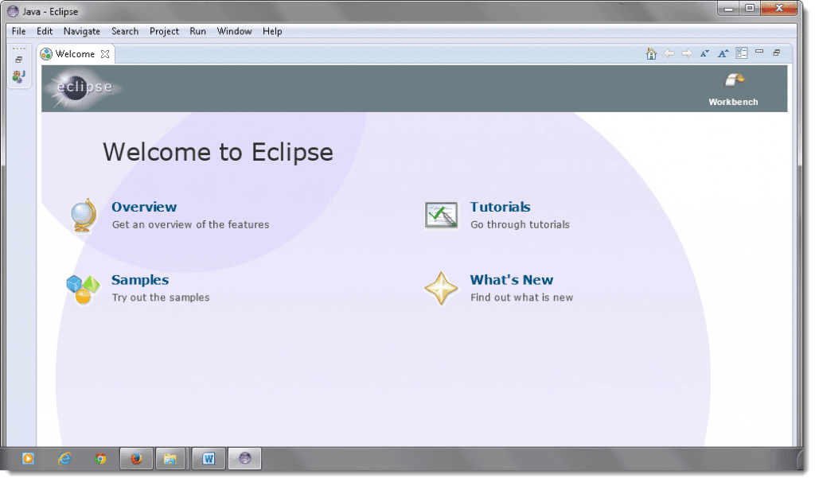

11) Now that you have finished installing eclipse restart your computer. By restarting your computer it refreshes system memory and allows changes made by installers and uninstallers to take effect.

**MAVEN**

Maven is a build tool. It is a software project management tool that provides a new concept of project object model (POM). Maven increases reusability and takes care of most of build-related tasks. It helps in bypassing my steps like adding jars to the project library, building reports, executing Junits test cases, creating Jar etc.

**DOWNLOAD MAVEN AS PLUGIN IN ECLIPSE**

1. Click Help from top menu in Eclipse & Select Install New Software

2. Click on the ***Add***button on the newly opened window.

3. In the Name box, type ‘**Maven**‘ and in the Location box, type ‘***http://download.eclipse.org/technology/m2e/releases/***‘

4. A check-box will appear in the pop window, ***Check*** the check-box and click on the ***Next*** button.

5. Please wait for some time and let the window complete its processing. It will not take long but 2 or 3 minutes.

6. Keep the default settings and click on the ***Next*** button.

7. Accept the ‘*Terms and Conditions*‘ and move forward by clicking on the *Finish* button.

8. Wait while it finishes the installation.

9. Once the installation is finished, it will ask you to restart the Eclipse. Please click on ***Yes***, so that changes can be reflected properly.

**DOWNLOAD AND CONFIGURE MAVEN**

PRE-CONDITION- JAVA IS INSTALL IN THE SYSTEM

1. Go To <https://maven.apache.org/download.cgi>

2.  Extract it to some location.You can choose your own location.

3. Set up the ***Maven Environment Variable*** the same way we set up the Java Environment Variable above.

4. Write ‘***MAVEN_HOME***‘ in the Variable name box then enter ‘***Your downloaded path of Maven***‘ Maven path in the Variable value box and click ***OK***.

5. Update the PATH variable just as JAVA and provide the path till the bin folder of mvn.

6. Open command prompt & enter ‘mvn -version’

7. You should be able to see the version of the mvn installed

**LAUNCHING BROWSER**

public class ChromeBrowserLaunchDemo {s

public static void main(String[] args) {

//Creating a driver object referencing WebDriver interface

WebDriver driver;

//Setting the webdriver.chrome.driver property to its executable's location

System.setProperty("webdriver.chrome.driver", "/lib/chromeDriver/chromedriver.exe");

//Instantiating driver object

driver = new ChromeDriver();

//Using get() method to **OPEN A URL**

driver.get("https://www.madridsoftwaretrainings.com/");  
  
 //Using getTitle() method to get the title of the WebPage  
 driver.getTitle();  
  
 //  
 driver.refresh();

//Closing the browser

driver.quit();

}

}